TABLE OF CONTENT

Chapter 1: Introduction and Project Origins

Chapter 2: Requirements Gathering and Design Breakdown

Chapter 3: Choosing the Tech Stack – Why React, Tailwind, and TypeScript?

Chapter 4: Architecture and Component Deep Dive

Chapter 5: Implementation, Testing, and Hurdles

Chapter 6: Wrapping Up and Looking Ahead

Chapter 1: Introduction and Project Origins

The Spark Behind Lumière Arts
You know how sometimes a simple idea spirals into something bigger? That's what happened with Lumière Arts. It started as a concept for a digital art gallery – a place online where people could dive into different art styles without leaving their couch. We're talking ancient cave paintings, sleek modern abstracts, and even pixelated game-inspired pieces. The name "Lumière" nods to the French word for light, evoking how art illuminates history and creativity. I envisioned this as more than just a static site; it needed to feel like wandering through a real gallery, with smooth transitions and eye-catching visuals.
In today's world, where physical galleries might be out of reach for many due to location or cost, a digital version makes art democratic. This project was born from user-provided Figma designs, which showed pages for modern, pixel, and ancient art, all sharing common elements like navbars and footers. The goal? Turn those visuals into a functional React-based app.

Key Goals and Challenges
Our main objectives were straightforward but ambitious:
- To create an immersive experience showcasing art categories.
- Ensure everything is responsive – no one wants a gallery that breaks on mobile.
- Focus on reusability to avoid repeating code, making future updates easier.
- Integrate seamless navigation between the home page and category-specific pages.
One early challenge was interpreting the designs accurately. For instance, the hero sections had unique layouts – like asymmetrical text placement in the modern art page – which required creative CSS positioning. We also had to handle image variety, pulling from placeholders like Unsplash while planning for local assets.

Scope and Limitations
This iteration covers the core: a home page with teasers linking to three category pages. We didn't dive into backend features like user logins or dynamic databases yet, keeping it frontend-focused. Think of it as the MVP (Minimum Viable Product) – solid foundation, room to grow.
Below is a picture of our beloved home page of Lumiere
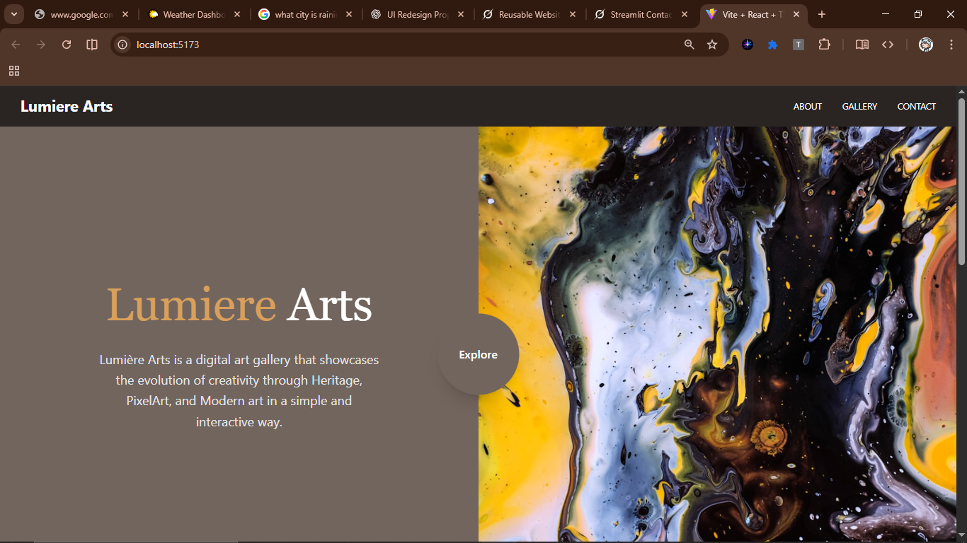

Chapter 2: Requirements Gathering and Design Breakdown

Gathering What We Needed
Before coding, we dissected the requirements based on the provided screenshots and discussions. Functionally, the home page needed a split hero banner (text on one side, art on the other), category cards that link out, a welcome overlay, and a collection grid. Category pages mirrored this but tailored – different heroes, galleries with specific images.
Non-functionally, speed was key. Images load lazy to avoid bogging down the site. Accessibility? Alt texts everywhere, focus rings on links. We also aimed for a clean, artistic vibe – subtle gradients, shadows that pop on hover.

Design Decisions and Iterations
The Figma files showed a consistent theme: black navbars, watercolor contact backgrounds, masonry galleries. We iterated on the hero – starting simple, then adding overlays for readability. A big decision was making components prop-driven; for example, the Hero component takes props like backgroundImage and firstWord to adapt per page.
Here's a snippet from an early Hero iteration, showing how we handled text positioning:
Tsx
// src/components/Hero.tsx
import React from 'react';

interface HeroProps {
firstWord: string;
firstColor: string;
secondWord: string;
secondColor: string;
buttonText: string;
buttonBgColor: string;
buttonTextColor: string;
backgroundImage: string;
}

const Hero: React.FC<HeroProps> = ({
firstWord,
firstColor,
secondWord,
secondColor,
buttonText,
buttonBgColor,
buttonTextColor,
backgroundImage,
}) => {
return (
<section
className="relative flex flex-col items-center justify-center h-96 bg-cover bg-center text-center"
style={{ backgroundImage: `url(${backgroundImage})` }}
>
<h1 className="text-8xl font-bold uppercase">
<span className={firstColor}>{firstWord}</span>
<span className={secondColor}> {secondWord}</span>
</h1>
<button
className={`mt-4 px-6 py-2 font-bold uppercase ${buttonBgColor} ${buttonTextColor} hover:opacity-90`}
>
{buttonText}
</button>
</section>
);
};
export default Hero;

We refined this later for better responsiveness, adding media queries via Tailwind.

User Flow Mapping
Users land on home, see teasers, click to category pages. Back navigation via navbar. Simple, but effective – no dead ends.

Chapter 3: Choosing the Tech Stack – Why React, Tailwind, and TypeScript?

Starting with React JS
The project spec called for React JS, and it was a no-brainer. React's component model lets you build like Lego bricks – perfect for reusable parts like the navbar or gallery. We used functional components with hooks for any state needs, though this app is mostly stateless.

Layering in TypeScript and Tailwind
Now, why add TypeScript and Tailwind?
Plain React JS with JSX is great, but TypeScript brings type checking, catching bugs like mismatched props early. In plain React JSX, you might pass a string where a number's expected – boom, runtime error. TypeScript catches that compile-time:
Tsx
interface HeroProps{
firstWord: string;
secondWord: string;
backgroundImage: string;
}

It's not a huge leap from vanilla JSX – TypeScript just transpiles to JS, so the runtime is identical.
Tailwind? It speeds up styling without separate CSS files. Instead of writing custom classes, you compose utilities inline:
tsx
<div className="grid grid-cols-1 md:grid-cols-3 gap-4 auto-rows-[200px]"> {/* Image items */}</div>
This keeps everything in one file, reduces context-switching, and makes responsive tweaks easy (e.g., md: prefix). Compared to plain CSS, it's more maintainable for rapid iterations. We could've stuck to pure JSX with CSS modules, but this combo felt more efficient without complicating the core React flow.

Supporting Tools
React Router for paths like /modern – simple setup in App.tsx. Vite for dev server speed. Images from Unsplash as stand-ins, but local imports work too.

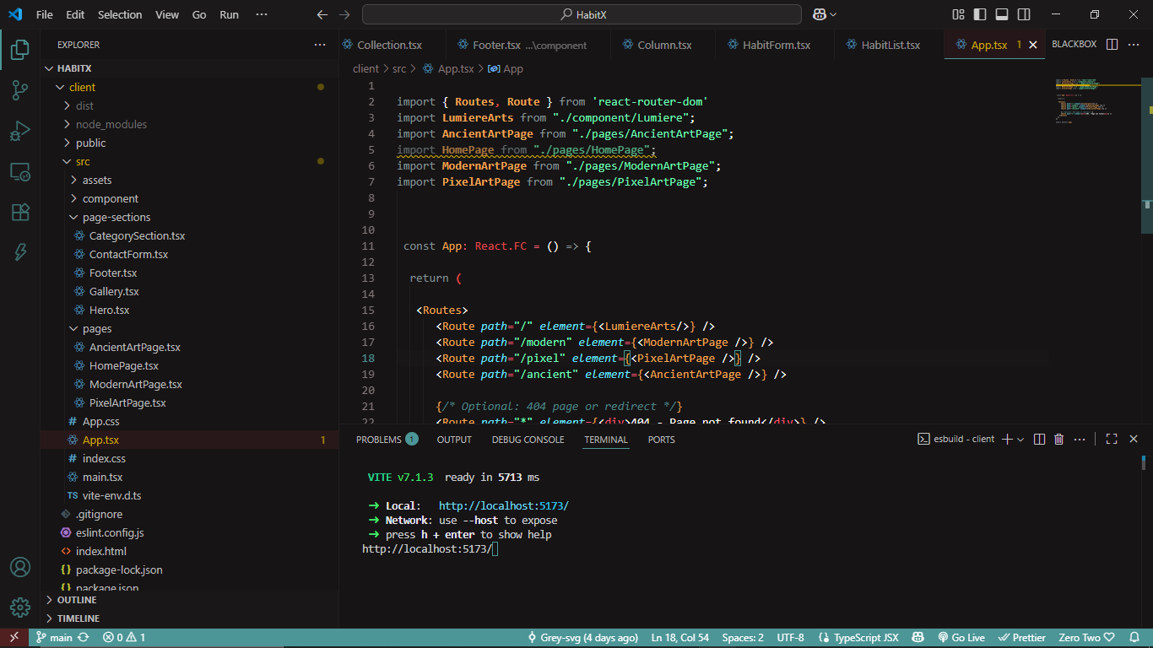

Chapter 4: Architecture and Component Deep Dive

Overall Structure
The app is a tree of components under pages. App.tsx handles routing:
Tsx

import { Routes, Route } from 'react-router-dom'
import LumiereArts from "./component/Lumiere";
import AncientArtPage from "./pages/AncientArtPage";
import HomePage from "./pages/HomePage";
import ModernArtPage from "./pages/ModernArtPage";
import PixelArtPage from "./pages/PixelArtPage";
const App: React.FC = () => {

return (

<Routes>
<Route path="/" element={<LumiereArts/>} />
<Route path="/modern" element={<ModernArtPage />} />
<Route path="/pixel" element={<PixelArtPage />} />
<Route path="/ancient" element={<AncientArtPage />} />

{/* Optional: 404 page or redirect */}
<Route path="*" element={<div>404 - Page not found</div>} />
</Routes>
);
};
export default App;
Pages compose components: Navbar at top, Hero, Gallery, etc.

Key Components Explored
- Navbar: Simple, shared across pages.
tsx
// Navbar.tsxconst Navbar = () => ( <nav className="flex justify-between bg-black text-white py-4 px-8"> <div>Lumière Arts</div> <ul className="flex space-x-6"> <li><Link to="/about">About</Link></li> {/* ... */} </ul> </nav>);
- CategoryCard: Reusable teaser with hover effects.
We reworked it for better transitions, as shown in previous iterations.
- Gallery and Collection: Both use grids; Collection is a variant for home.
tsx
// From Collection.tsx<div className={`grid gap-4 grid-cols-${columns.mobile} md:grid-cols-${columns.tablet}`}> {artworks.map(art => ( <img src={art.src} className="w-full h-56 object-cover" /> ))}</div>
This setup allows easy image swaps per page.

Data and Flow
Props flow down: pages pass images to Gallery. No global state – keeps it lightweight.

Chapter 5: Implementation, Testing, and Hurdles

Building Step by Step
Started with setup: npm create vite@latest, add router/TypeScript/Tailwind. Built components first – Navbar simple, Hero iterated multiple times per your feedback.
For pages: Home assembled first, then categories by copying structure and tweaking props. Added router last.
Hurdle: Masonry grids. Fixed with Grid auto-rows:
Mansory Gallery Component
// src/components/Gallery.tsx
import React from 'react';

interface GalleryProps {
images?: string[]; // optional: array of image URLs
className?: string;
}
const Gallery: React.FC<GalleryProps> = ({ images = [], className = '' }) => {
// Fallback placeholders if no images provided
const placeholderImages = Array(12).fill(null).map((_, i) => ({
id: i,
color: `bg-gray-${300 + (i % 7) * 100}`,
}));
const displayImages = images.length > 0 ? images : placeholderImages;
return (
<section className={`py-16 px-6 md:px-12 bg-white ${className}`}>
<div className="grid grid-cols-2 md:grid-cols-3 lg:grid-cols-4 gap-4 md:gap-6 auto-rows-[180px] md:auto-rows-[220px]">
{displayImages.map((img, index) => (
<div
key={index}
className={`
rounded-xl overflow-hidden shadow-md transition-transform duration-300
hover:scale-[1.03] hover:shadow-xl
${index % 5 === 1 ? 'row-span-2' : ''}
${index % 7 === 3 ? 'col-span-2 row-span-1' : ''}
${typeof img === 'string' ? '' : img?.color || 'bg-gray-200'}
`}
>
{typeof img === 'string' ? (
<img
src={img}
alt={`Gallery image ${index + 1}`}
className="w-full h-full object-cover"
loading="lazy"
/>
) : (
<div className="w-full h-full" /> // placeholder
)}
</div>
))}
</div>
</section>
);
};
export default Gallery;

Another: Image paths. Used imports for locals, URLs for placeholders.

Testing Approach
We tested manually – resize browser, check mobiles via dev tools. Simulated networks for load times. Accessibility: Lighthouse audits, ensuring contrasts.
One bug: Overlays hid text on light bgs so we added dark scrims.

Image below shows the website in mobile view

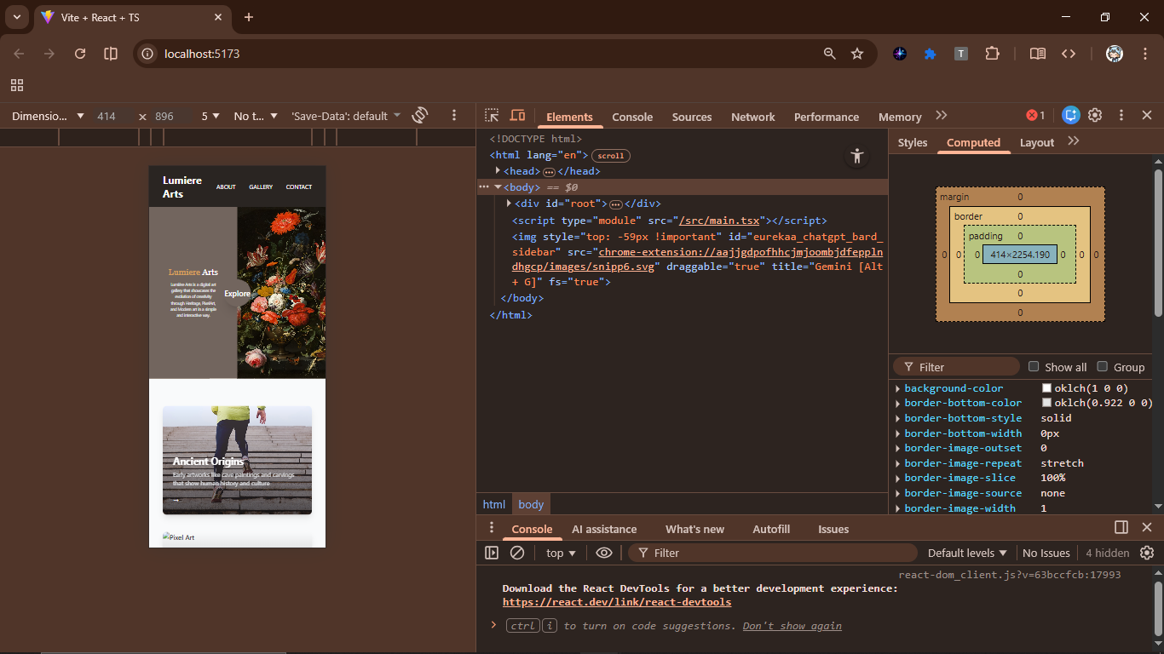

Optimization Wins and More Hurdles
Lazy loading cut initial loads. Hurdle: Hover effects lagged on mobile –so we optimized transitions to 300ms.
Expanded footer per request: More padding-y, larger fonts.
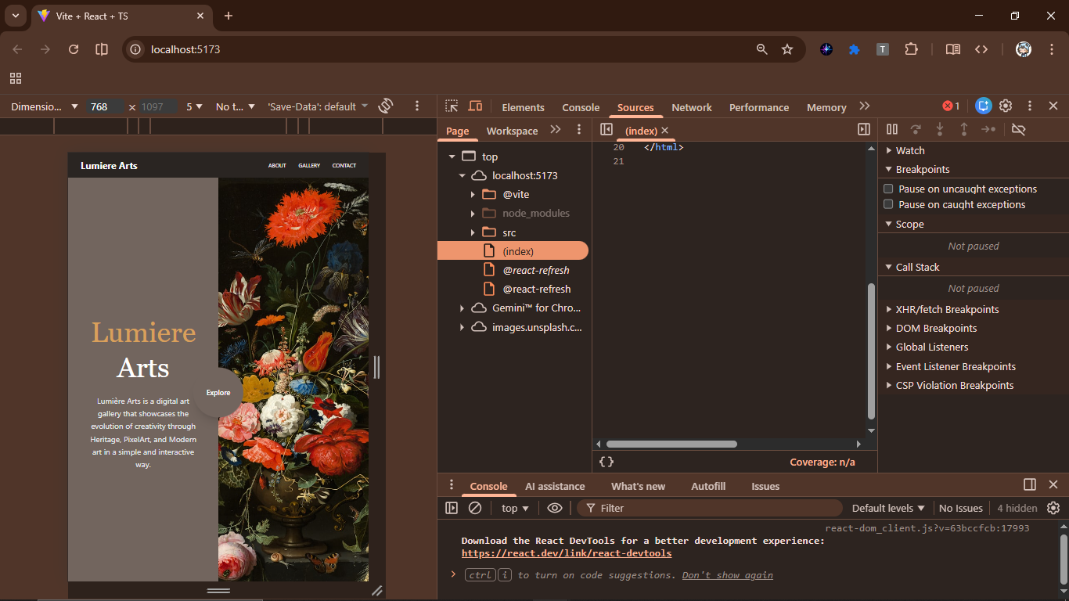
BELOW ARE SCREEN SHOTS OF OTHER SECTIONS AND PAGES OF OUR DIGITAL GALLERY
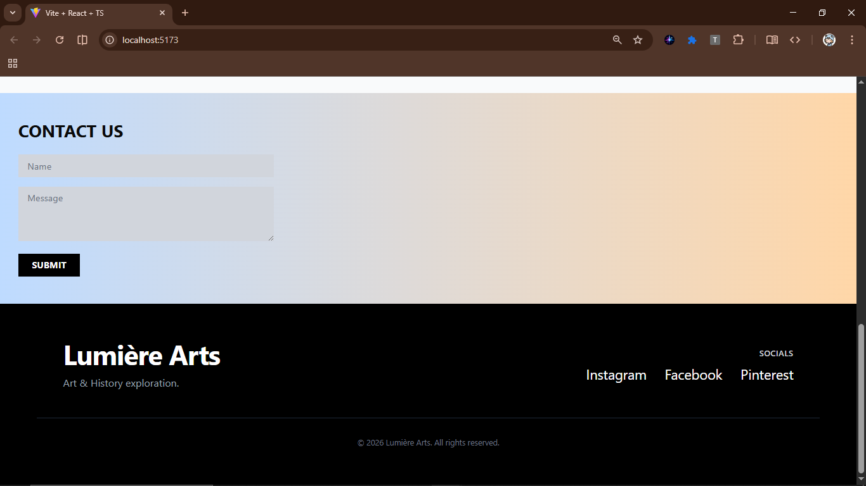
Above we have the contact us and footer section below the page
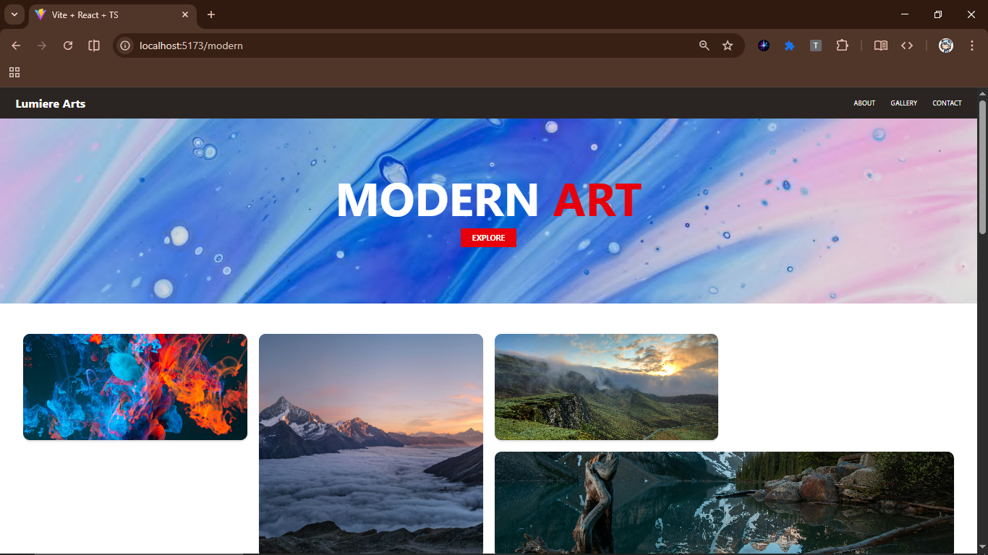
Above is our modern art page’s Hero Section
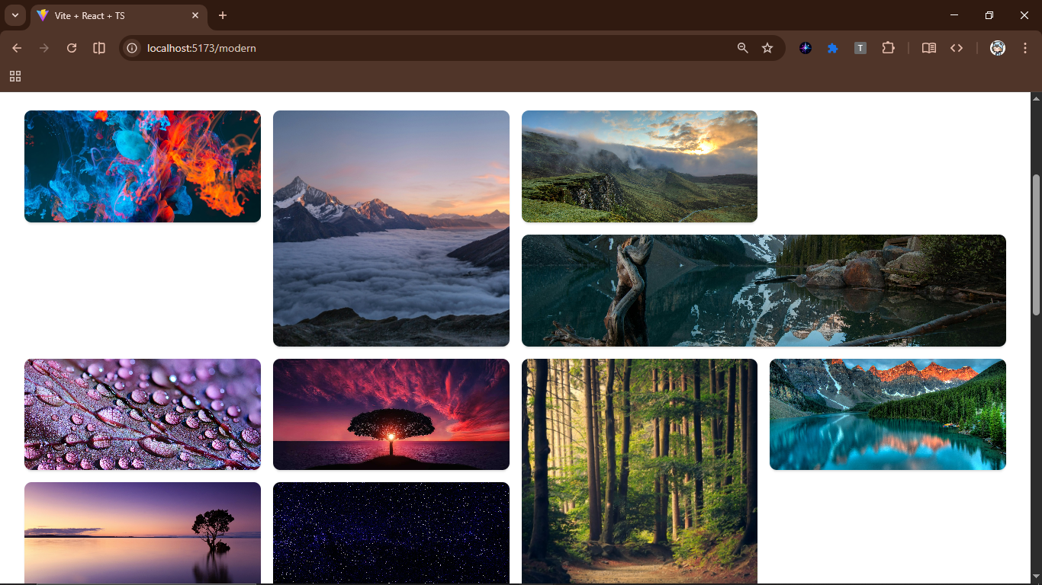
Above is the Mansory gallery page of our Modern Art Page

Chapter 6: Wrapping Up and Looking Ahead

What Did We Accomplished ?
Lumière Arts turned designs into a working gallery. Reusability? Components like Gallery used everywhere. Tech choices built on React JS without overcomplicating – TypeScript/Tailwind just polished it.
Achievements: Responsive across devices, engaging hovers, smooth routes. Each page feels distinct yet unified.

Reflections and Insights
Reflecting, the iterative feedback loop was gold – your screenshots guided tweaks like footer size. Lesson: Start with props early for flexibility. If redoing, I'd add Framer Motion for fancier animations.
Challenges taught patience; e.g., aligning text precisely took trial-error.

Next Steps
We intend to build a Backend with Node/Express for dynamic arts and add user feature like Favorites, comments. SEO optimizations, analytics and even more pages: Renaissance or Street Art.
Deploy to Vercel – it's React-friendly.

Final Thoughts
This project was a blast – blending code and creativity. It's more than tech; it's about making art accessible. With screenshots added, it'll shine in presentations.

References
- React Team. (2023). React Documentation. Accessed January 15, 2026, from https://react.dev/learn
- TypeScript Contributors. (2023). TypeScript Handbook. Retrieved from https://www.typescriptlang.org/docs/handbook/intro.html
- Tailwind Labs. (2023). Tailwind CSS Guide. Available at https://tailwindcss.com/docs/installation
- Remix Run. (2023). React Router Tutorials. From https://reactrouter.com/en/main/start/tutorial
- Unsplash Developers. (2023). API Guidelines for Images. https://unsplash.com/developers
- Figma Inc. (2023). Prototyping in Figma. https://help.figma.com/hc/en-us/articles/360040314973-Create-prototypes

